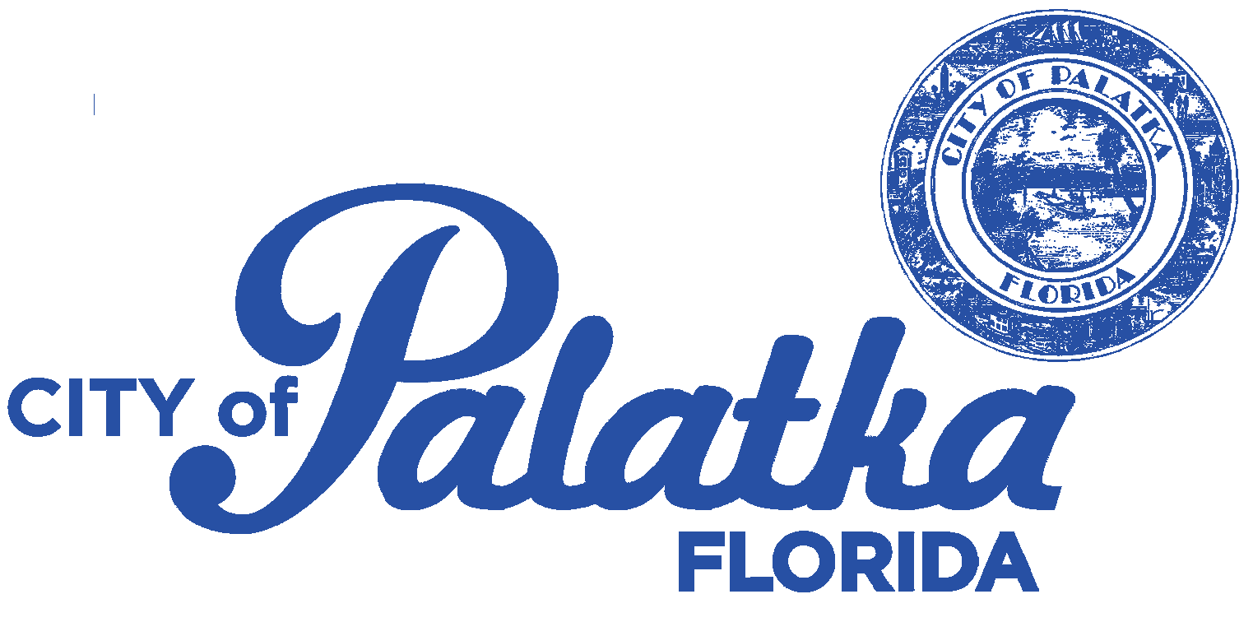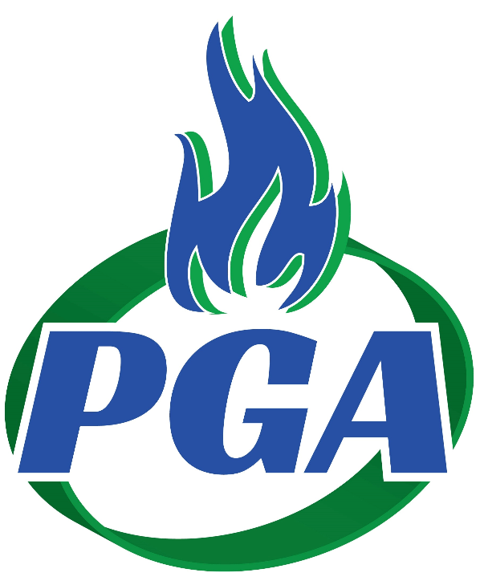 **Introducing our *new* statement**

Effective May 01, 2017, Gas, Water, Sewer and Garbage billing have been combined to provide more information in an easy to read and understand format. All payments and inquires will be handled by Palatka Gas Authority at 518 Main Street, (386) 328-1591. One payment location, mailing address and phone number for all City Utilities. (See Back for ALL Payment Options)

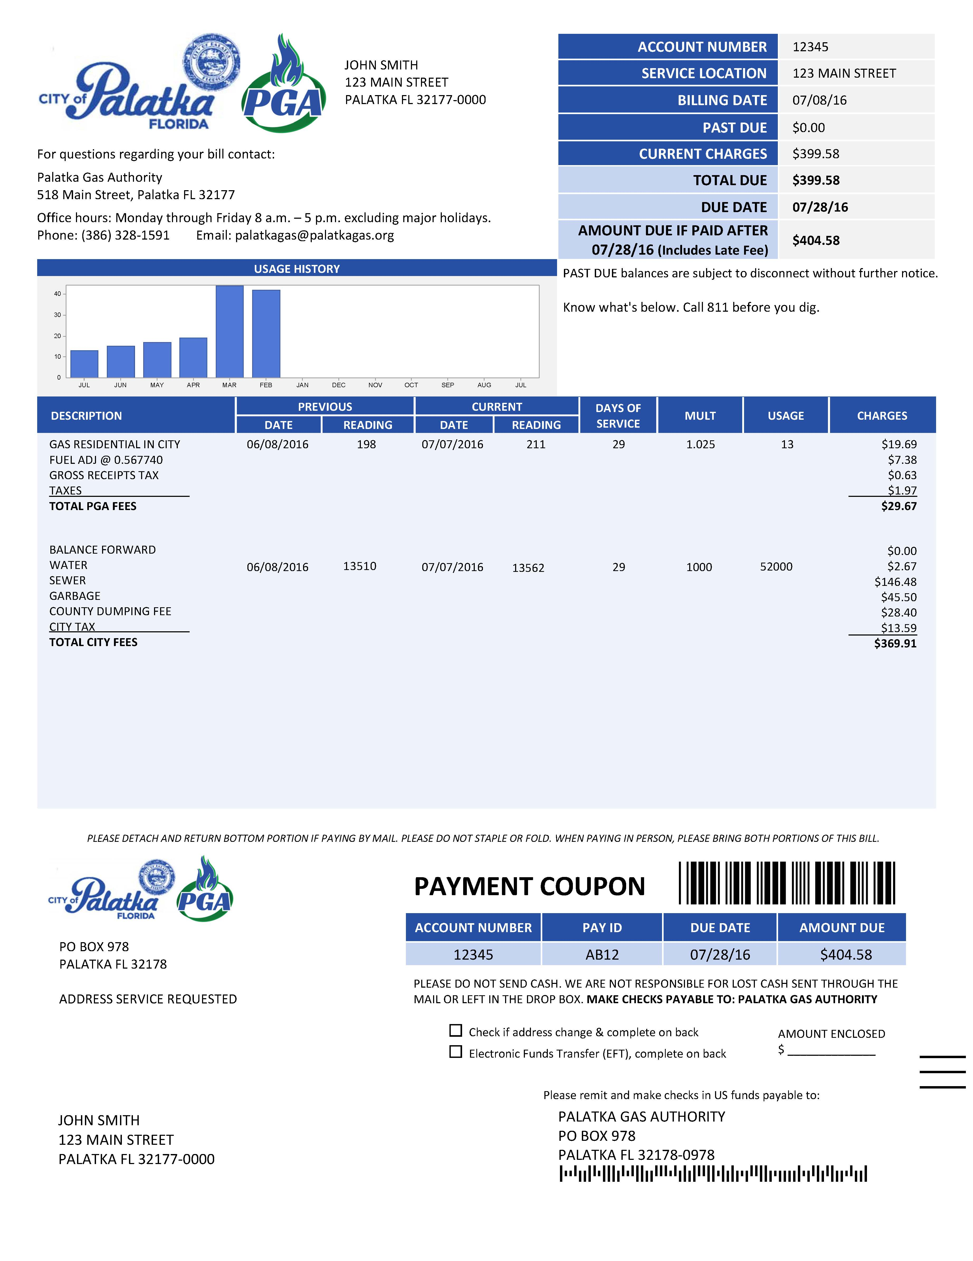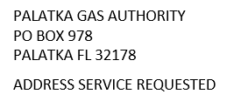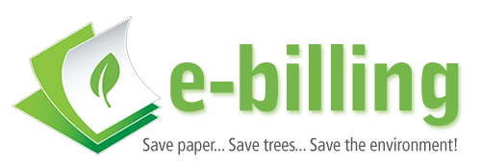

Gas service billing period, meter reads, days of service, multiplier, usage and charges.

Water, Sewer, & Garbage billing period, meter reads, days of service, multiplier, usage and charges will be listed separately

Contact information for billing or service questions

Account Summary to quickly find your service address, amount due and due date

Usage graph comparison

Payment Coupon – to be returned with your payment; please do not send cash

Please ensure the address is showing thru the envelope window

Make checks payable to Palatka Gas Authority for total amount due

Important messages will be displayed here

**SAMPLE**

To receive your bill by email - visit palatkagasauthority.com and sign into your account; under Account Management select Bill Options; you will have the option to select email or email & paper bill. It is really that easy!